# Results

## Mechanical Design, Fabrication, & Verification

Throughout our mechanical build process, we took measures to ensure our cuts, drills, etc… were being made to specification. The use of dial calipers and other measurement tools allowed us to maintain high precision throughout. Additionally, the machine shop can machine down to a .001” precision.

Our end product, the synthesis of our mechanical build process, was a refined, tuned machine. The rubber grips allowed the display to not slide on the display table. Additionally, we used stage weights as a back-up measure to ensure the folding table didn’t crash.

Our meticulous balancing of the blades proved to be successful and we were able to rotate at a consist 1800 RPM. Speed measurements were verified throughout with a tachometer. Additionally, the clear acrylic safety shield added two layers of refinement. For one, it gave people piece of mind that our project wouldn’t kill them and additionally, it worked excellently as a sound buffer.

The most important aspect of our design was the upper bearing that we installed. It kept the shaft from coming out of balance and worked exactly as expected. Even though we still had vibrations, the counter-clockwise rotation ensured that the nuts only ever tightened.

## Hardware Design and Verification

For our hardware synthesis, all systems worked very well together. Our carefully designed system was able to intricately inter-communicate and display crisp clean images.

Our concerns with power draw proved not to be a huge issue, as the 18 gauge wire was able to supply enough current up to the blades without melting or breaking. One thing we did observe is that bearing that start to cut away at the rubber sheathing on the wire.

The power supply we used was able to run the control panel, the motor/speed controller, and all the boards and the LEDs comfortably. Using a 270W PC power supply proved to be very convenient because it gave us high power supplies of all the common voltages we could ever need (3.3V, 5V, 12V).

The 3mm LEDs gave us a great fine resolution display and were very bright, even in the harsh lighting of the atrium. Additionally, the ATmega 328p microcontrollers did a great job of controlling all the onboard systems.

## PCB Design and Fabrication

Our PCBs that were printed through ExpressPCB looked excellent and very professional. Outside of 3 minor issues (that were easily fixable), production went off without a hitch for the second revision.

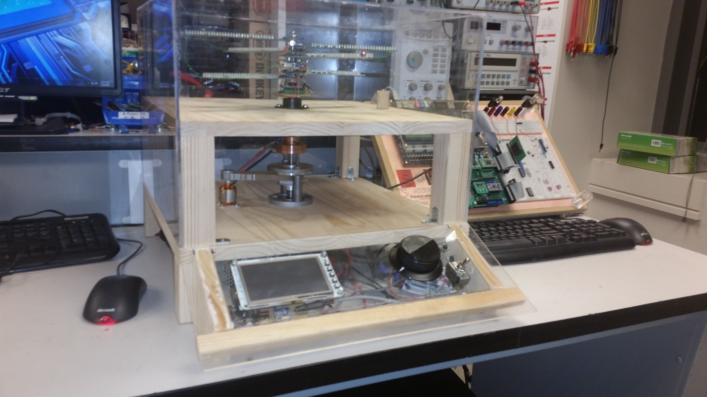

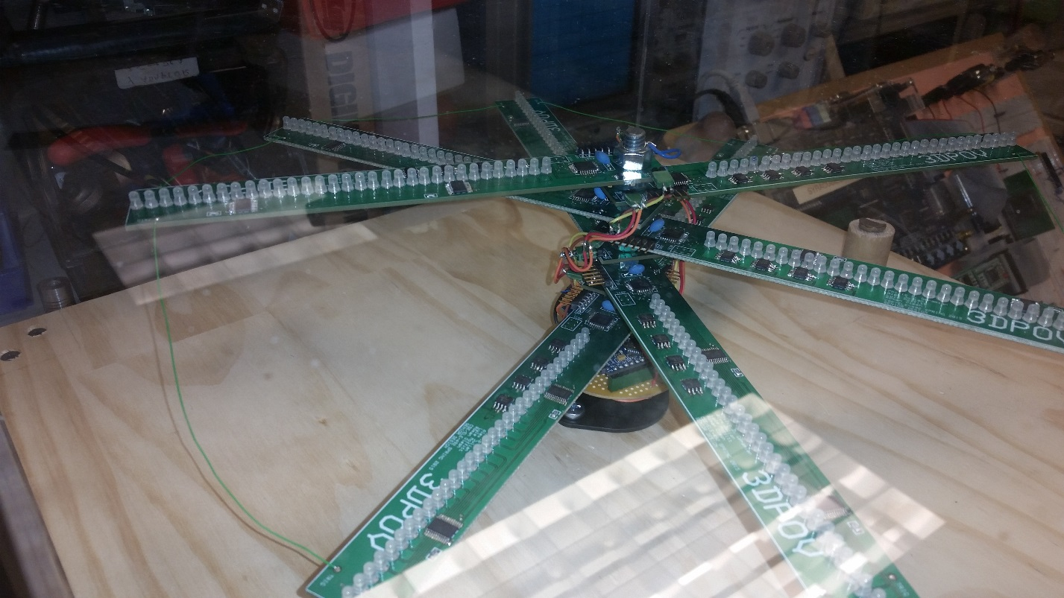

<insert figure labels for these>